1. **Sequence diagram**

**1.1 Account Login and Update**

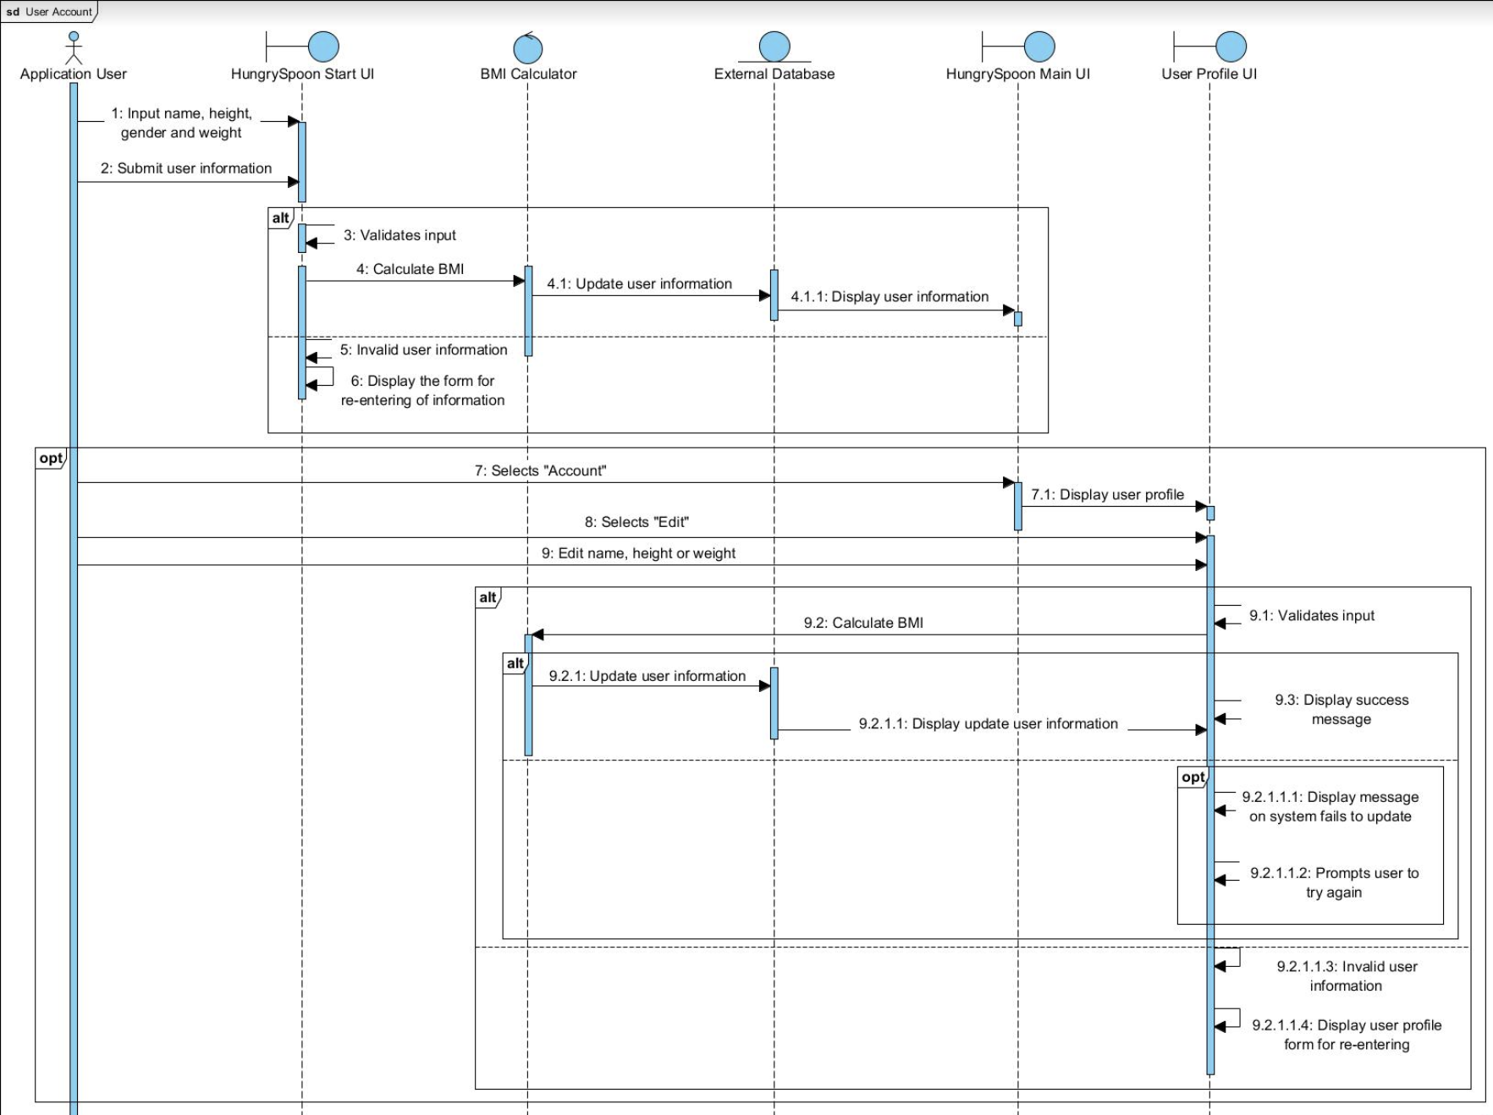

Figure - Sequence diagram for user account

**1.2 Food Generator**

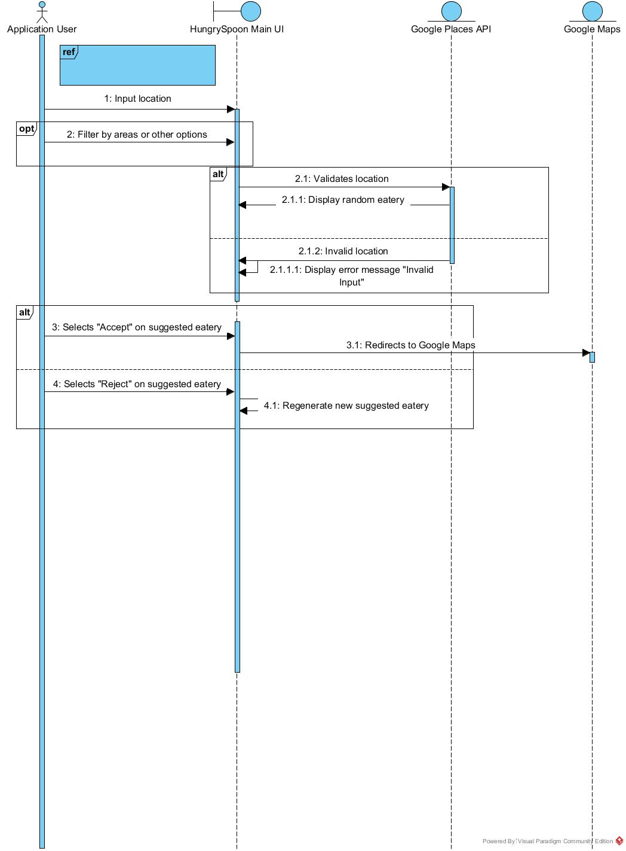

Figure - Sequence diagram for food generator

**1.4 Calories Counter and Exercise Recommendation**

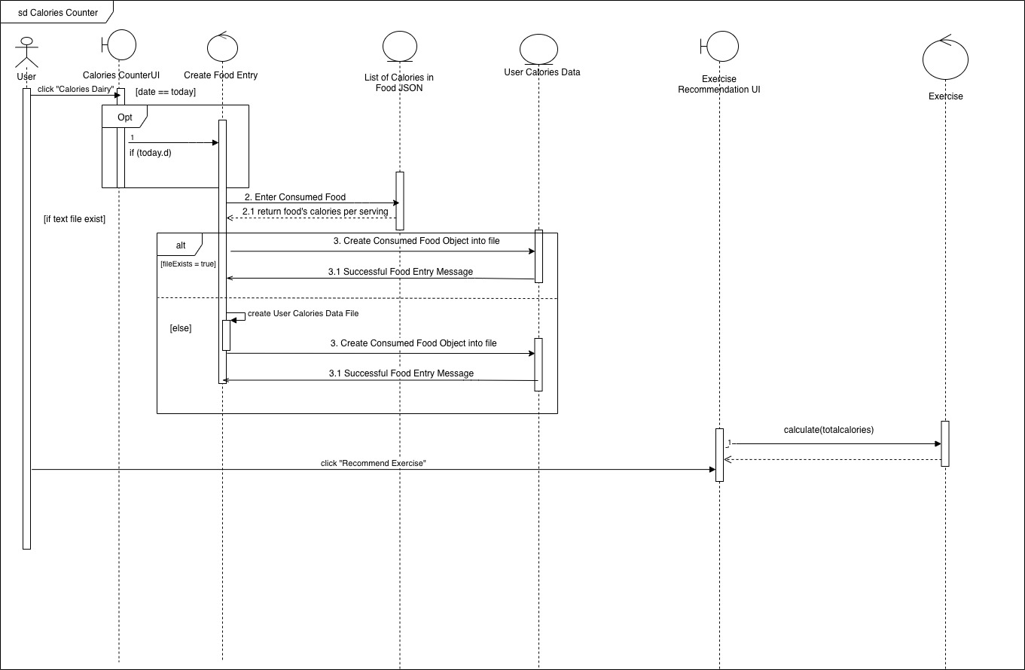

Figure 3 - sequence diagram for calories counter

**1.5 Locate Parks**

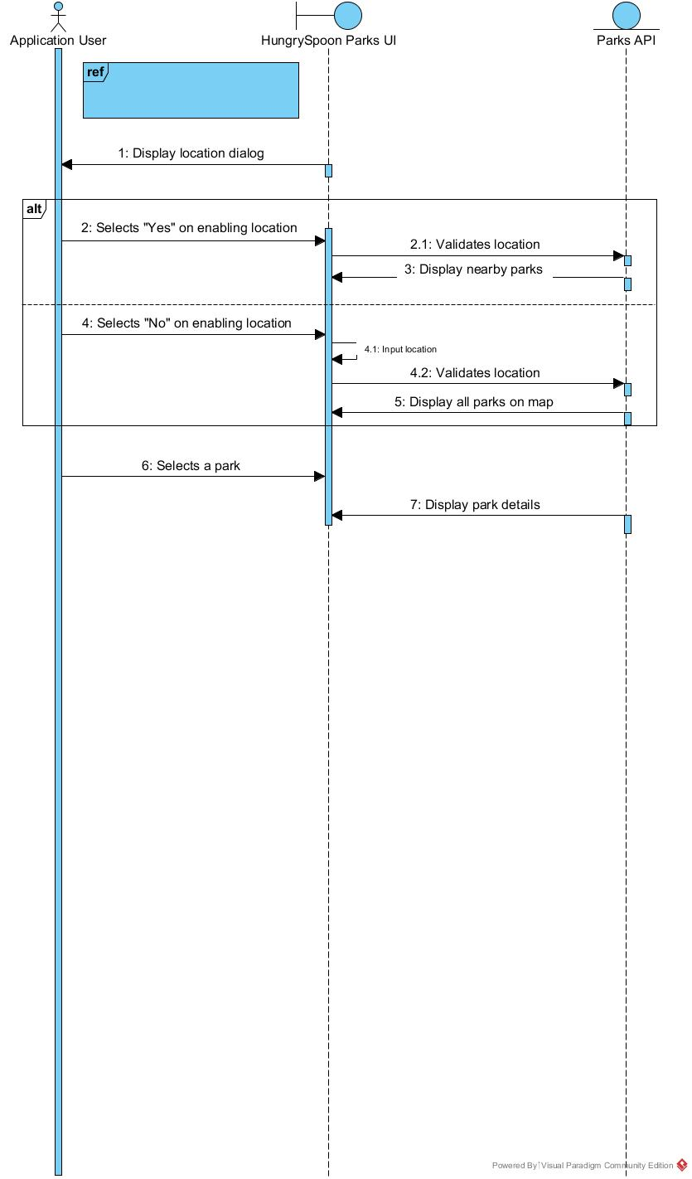

Figure 4 - sequence diagram for locate park